JUMP HEIGHT
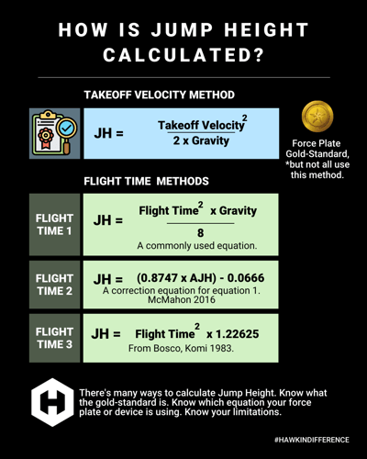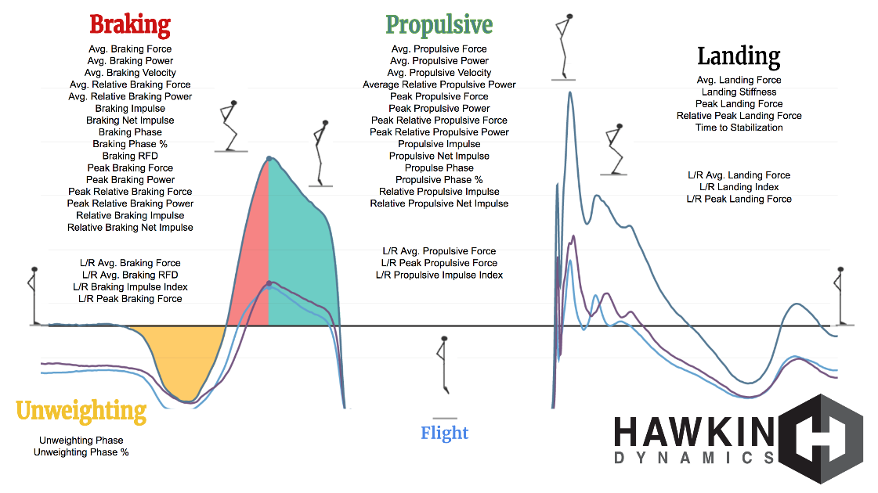

https://www.physio-pedia.com/Vertical_Jump_Test
https://ovrperformance.com/blogs/news/vertical-jump-height-for-men-science-backed-benchmarks-proven-ways-to-improve
https://www.cavs.msstate.edu/publications/docs/2020/05/164646088-12858-1-SM_2.pdf

